Paper title goes here: YU-WRITE submission template (25 words MAX)
Author’s Name, Institution Affiliation, City, Country

Abstract
Your abstract should be no longer than 150-200 words. An abstract describes the main purpose, methods, and outcome of your study. What we look for in this section: Is the abstract within the word-limit? Does the abstract outline clearly what to expect in the author(s)’ submission? If applicable, does the abstract include references pertinent to understanding the paper?
Keywords: style; formatting; linguistics; publishing

DO NOT FILL THIS OUT! Author Name: Researcher’s bio must be 1-2 sentences max. This can include your degree(s), program, and research interests. You can also add your website or email. Do this for all author’s if needed. (To be filled out if manuscript is accepted for copyediting)

Introduction
You can download the Word version of this document and paste your paper into the template using the styles that are already in place. The main text of your paper should be displayed in “Body Text” style (11-12-point Calibri, Arial, or Times New Roman font, double-spaced, employs italics, rather than underlining (except with URL addresses) and 1-inch margins). Each paragraph must have the first line indented. The title of the headings and subheadings are up to you, but this template will highlight the contents we are looking for when reviewing your submission. What we look for in this section: Is the introduction clear? Does it indicate clearly what the author(s) are discussing about? Does the introduction outline the direction of the manuscript? Does the introduction grab your attention?
Theoretical Framework (if applicable)
Things we are looking for in this section: Is the theoretical framework cohesive to their central argument? If there are more than one theory used, are they complimentary and well justified? Are the theorists/theoretical framework used well researched and presented with nuance (is the author considering different perspectives/existing tensions to their particular theory)?
Subheadings
Subheadings/subsections must have the heading on the left. Content under that section follow the usual style guidelines. Any other nested headings must be indented and bolded (see below).
Subheading/subsection
Example of nested headings. Subheading/subsections can be used in any section.
Methods/Methodologies (if applicable)
What we look for in this section: Is the methodology well-developed? Are the methods clearly outlined and supported by scholarly work? Are concepts well-defined?
Findings and Discussion
What we look for in this section: Are the findings/discussions presented clearly? Are the conclusions logically developed from the findings? Are the findings supported with nuanced and differing perspectives? Are the chosen findings relevant and impactful? Are you left with questions about the findings? Is the author’s voice clear or are they mainly using the voice of the scholars that they are citing?
Conclusion
What we look for in this section: Does the conclusion summarize the submission’s overarching discussions? Does the conclusion include significance to their overall research fields? Does the conclusion leave lasting impressions to the reader/you?

Figures and Tables
All figures and tables must be referred to in text and should be displayed either immediately before or after the paragraph in which they are first referred to. Please include figures in your text WITH ALT-TEXTS and centred (please see Accessibility Concerns for more details).
Figures include charts, tables, and images. If you have charts imported from Excel, you must save them as a JPEG file to copy and paste separately. All figures must be created by the author. If you are using figures from another source, you must receive permission from the image holder. If using images, the images can either be imbedded into the body of the paper or be at the end in a Figure List.
All figures must be numbered and accompanied by a caption. The caption serves as the ‘title’ of your figure and hence should not exceed three lines long. Captions should be placed below the figure and displayed in the “Figure Caption” journal’s style (11-12 pt, Calibri, Arial or Times New Roman, centred). The caption should begin with “Figure #.” as shown in Figure 1, below.
Accessibility concerns
Figures should have alt text assigned. This can be done through the Picture Format pane in Word. Alt text should provide a clear description of what is visible in the figure. Because alt text cannot always fully describe a figure, please also ensure that any important information displayed in a figure is also communicated in text. Please also note that figures should not rely exclusively on colour to communicate information. To check this, please view your figures in black and white and ensure that all of the information you intend to convey is still communicated by the colourless version of the figure.
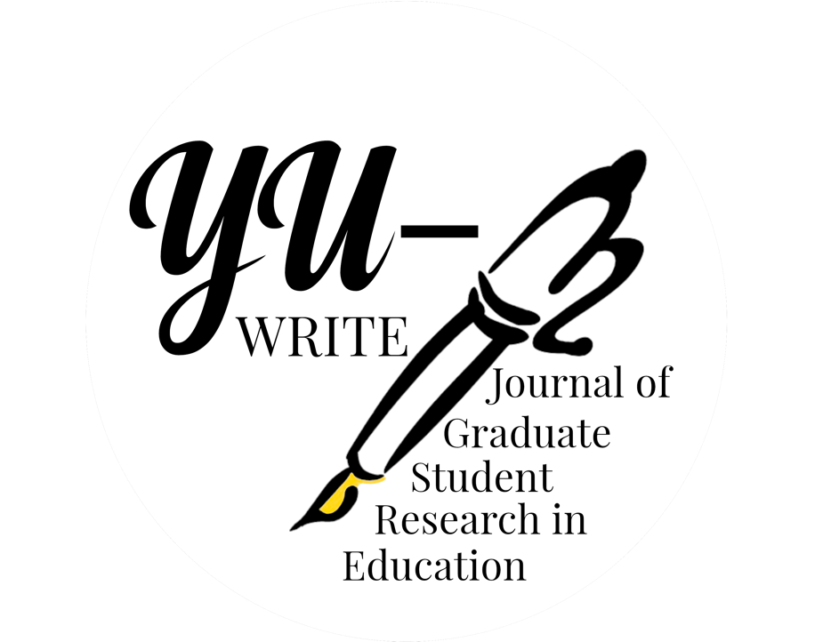
Figure 1: This is a figure caption for the YU logo.
Alt-text embedded in the image: A black and white drawing of a fountain pen with a golden tip. Text reads: YU-WRITE Journal of Graduate Student Research in Education.

Tables
Tables may be used to display numerical and textual data. Tables should be editable and included in text. Horizontal lines may be used. Vertical lines should not be used (as shown in Table 1, below).
Table 1. This is a table title.
 | Column header | Column header | Column header
Row title | 2 | 4.23 | Yes
Row title | 1 | 6.00 | No

All tables must be numbered and titled in “Table Title” style (11-12 pt, Calibri, Ariel or Times New Roman, justified, single spaced). Table titles should be placed above the table and should begin with “Table #.” as shown in Table 1, above. Titles should not exceed 2 lines in length. Tables should be followed by one blank line in “Body Text” style.

Footnotes
Footnotes should be kept to a minimum, as all relevant information should be included in your text. If footnotes are included, they may be created using the Word automatic “Insert Footnotes” tool. Footnotes should be numbered using Arabic numerals (i.e., 1,2,3,4…) and should be placed after punctuation marks. If using software other than Word, please note that footnotes should be displayed on the same page as the insertion point and should be displayed in 10pt, single spaced, Calibri, Ariel, or Times New Roman font, as in the example below here. Footnotes should not be used for citation information.
In-text citations
Any time you refer to another publication whether directly or paraphrasing, you must include an in-text citation. In-text citations should be displayed in APA Style (7th Edition) as shown in the example here (Author, 2020). When presenting a direct quote or a close paraphrase, the page number that the quote or paraphrase was drawn from must be included in the in-text citation as shown in the example here: (Author, 2020, p. 1). If you quote directly from the text and the quote does not exceed 40 words, it should be enclosed in double quotation marks.
If you quote directly from a text and your quote exceeds 40 words in length, please use the “Block Quotes” style (11-12 pt, Calibri, Ariel or Times New Roman, justified, with a left indentation). Be sure to include your in-text citation after the final punctuation mark in the block quote. (Author, 2020, p. 30)

The text immediately following a block quote should not be indented. See link in References List section for additional guidance. On the presentation of in-text citations.
Acknowledgements
Should you wish to thank any person or (funding) organization for their support or assistance with your paper, you may include an acknowledgements section directly preceding the References List. Please begin the section with the heading titled Acknowledgements in the journal’s style (11-12 pt, bold, Calibri, Ariel or Times New Roman, centered). The text of the acknowledgements should be displayed in “Body Text” style.

References
All references cited in text must be included in the references list on a separate page (page break). Your reference list should begin with the heading References in “References Heading” style (11-12 pt, bold, Times New Roman, centered). All references should be in “References” style (11-12 pt, Calibri, Arial or Times New Roman, LEFT with an ident) and should be formatted in accordance with APA Style (7th Edition) as in the templates below. OWL Purdue provides additional examples and guidance for citing other types of materials: https://owl.purdue.edu/owl/research_and_citation/apa_style/apa_style_introduction.html. You are also encouraged to use automatic referencing software where appropriate. What we look for in the references section: Are the in-text citations APA7 standard? Is the reference page APA7 standard? Is the author using a diverse range of scholars? Have the author(s)’ cited foundational scholars?
Example
References
Author, A. A., & Author, B. B. (2001). Title of chapter. In E. E. Editor & F. F. Editor (Eds.), Title of work: Capital letter also for subtitle (pp. pages of chapter). Publisher. DOI (if available)
Author, A. A., Author, B. B., & Author, C. C. (2005). Title of article. Title of Periodical, volume number(issue number), pages. https://doi.org/xx.xxx/yyyy
Author, A. B. (2020). Title of work: Capital letter also for subtitle. Publisher Name. DOI (if available)
Author, B. B. (2019, August). Title of article. Title of Newspaper, pages.
Author, E. E. (Year, Month Date). Title of page. Site name. URL
Editor, E. E. (Ed.). (1990). Title of work: Capital letter also for subtitle. Publisher. DOI (if available)
Appendix A: Title your appendix here
If you wish to provide any additional material as appendices, you may include it after the references list. Each appendix must be headed by a title in “Appendix Heading” style (11-12 pt, bold, Calibri, Arial or Times New Roman, centered). Name each appendix you include consecutively by letter of the alphabet, followed by a colon and then a descriptive title, e.g., “Appendix A: Transcription conventions”, “Appendix B: Survey instrument”. Appendix is featured after the References.
Figure List
All images/figures must have copyright permissions if it is not the author’s image. Permissions must be sent to the Journal Managing Editor. Figure List are featured after Reference and Appendix.
Figure 1: caption/title of image
[image pasted with alt text]
Figure 2: caption/title of image
[image pasted with alt-text]
Extra Notes
Each type of submission follows this structure or a variation of it. There may be some differences between each submission type. Thus, author(s)’ must be aware of any word counts, etc. Book/film/art reviews may use this structure with different headings.

This is a footnote.

